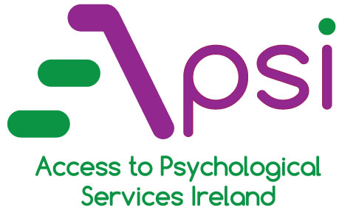
Primary Care Centre, Golf Links Road, Roscommon Tel: 090 6665020 Fax: 090 6627293
REFERRAL FORM
DETAILS OF PERSON BEING REFERRED
Name |  |  |  |  |  | Date of birth |  |  |  | / /
Address
Sex | Male |  | Female |  |  | GMS No. (IF APL.)
Phone No. | Landline |  |  |  |  | Mobile
Does this person have special needs?
(e.g., requires wheelchair access)
REFERRER DETAILS
Referrer name
Professional title
Address of referrer
Telephone/Mobile No. |  |  |  |  |  |  |  | Fax no.
Signature:
Date: / /
GP DETAILS (if different from above)
Name of GP
Address of GP
Telephone/Mobile no.
REASON FOR REFERRAL
Please describe the main presenting difficulties the person being referred is currently experiencing, the severity of these difficulties, and the duration:

RECENT STRESSORS
Are there any current or recent events/circumstances that may act as a significant source of stress for the person? If so, please specify:

RISK ASSESMENT
Current suicidal intent |  |  |  |  |  |  | Deliberate self-harm
Current suicidal risk |  |  |  |  |  |  | Risk of violence
Previous psychiatric hospitalisation |  |  |  |  |  |  | Current self-neglect
Previous suicide attempt |  |  |  |  |  |  | If present, number of attempts:
If urgent care is needed in relation to risk, please telephone the mental health acute unit (County Hospital, Roscommon) at 090 663 2325 (24 hrs).
MENTAL HEALTH TREATMENT
Is this person currently receiving treatment from another mental health service or have they been referred to another mental health service? If so, please specify:

Is this person being treated with medication for their mental health difficulties? If so, please specify:

MEDICAL HISTORY AND CURRENT TREATMENT
Please provide details of any relevant medical problems and any current medication/treatment?

SUGGESTED TREATMENT
Counselling Therapist-assisted psycho-education Computerised CBT Brief one-to-one CBT Psycho-educational group workshop
SERVICE USER CONSENT
Service user consents to be contacted by: (Tick as appropriate)
Landline Mobile Letter

